To: Supreme Insurance Company. Word count-233

From: Rubina Shaik, Anurag Lahon, Anamika Singh

Subject: Factors influencing insurance payments

Date: 02/26/2020

This summary reports on the factors that influence payments for medical malpractice.

EXECUTIVE SUMMARY

**Major Findings**

* The average payment with private attorney is more than the average payment without private attorney by approximately $686,000 (see Exhibit A).
* Private insurance has the highest payment with an average of $975,000 (see Exhibit B).
* 64% of the total payment is attributed to severity 6 to severity 9 (see Exhibit C).
* Higher severity is found in upper age groups (40 and above) and most of the high severity cases (6-9) are carried by private attorney which leads to high payments (see Exhibit D).
* In specialty, specialties like surgery (General surgery, Orthopedic surgery, Thoracic surgery and Urological surgery) have higher payment (average payment $734)( while specialties like medicine (Emergency medicine, Internal medicine, Physical medicine, Occupational medicine) have lowest payment(average payment $595) (see Exhibit E).

**Recommendations for Action**

* Insurance company should try to settle with private attorneys to lower the payments as payments with private attorneys are much higher than without private attorney.
* As payment are high for surgery, insurance company should increase the insurance cost for doctors practicing surgery.
* Insurance company should try to settle with patients with severity 6-9 and for lower payments.

**Analytical Overview**

The data were tabulated, and the average of payment were compared with each data separately. Descriptive stats of all the columns are observed and the factors contributing to the payments are recorded.

**Documentation Page**

Exhibit A. Relationship between average Payments and Private Attorney

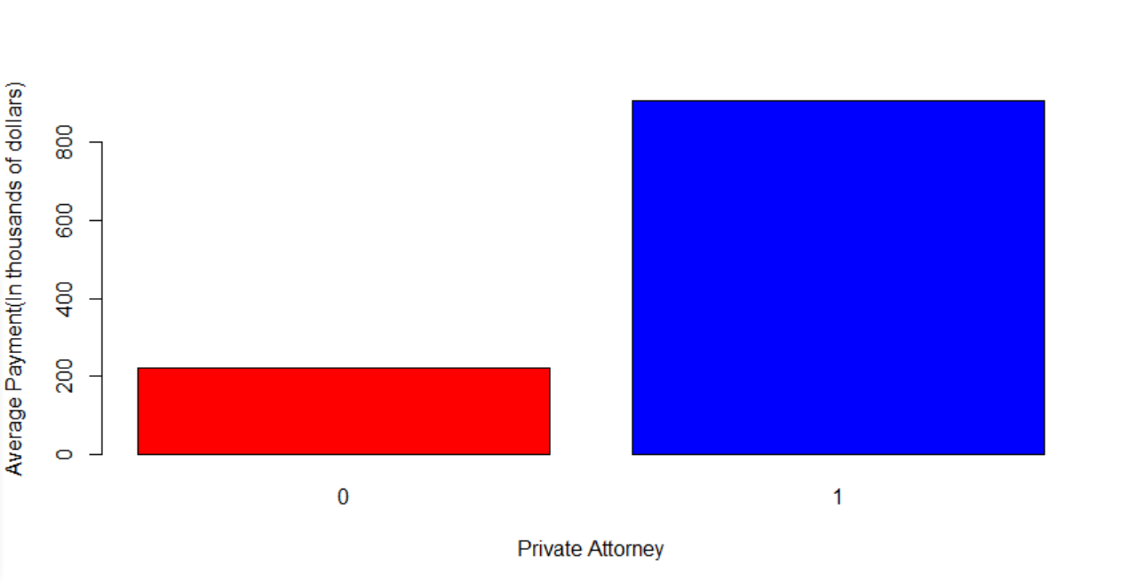

Exhibit B. Relationship between average Payments and Insurance

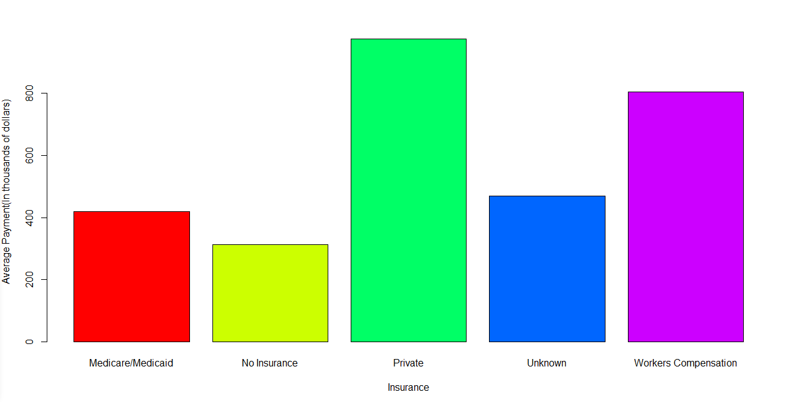

Exhibit C. Relationship between average payment and severity

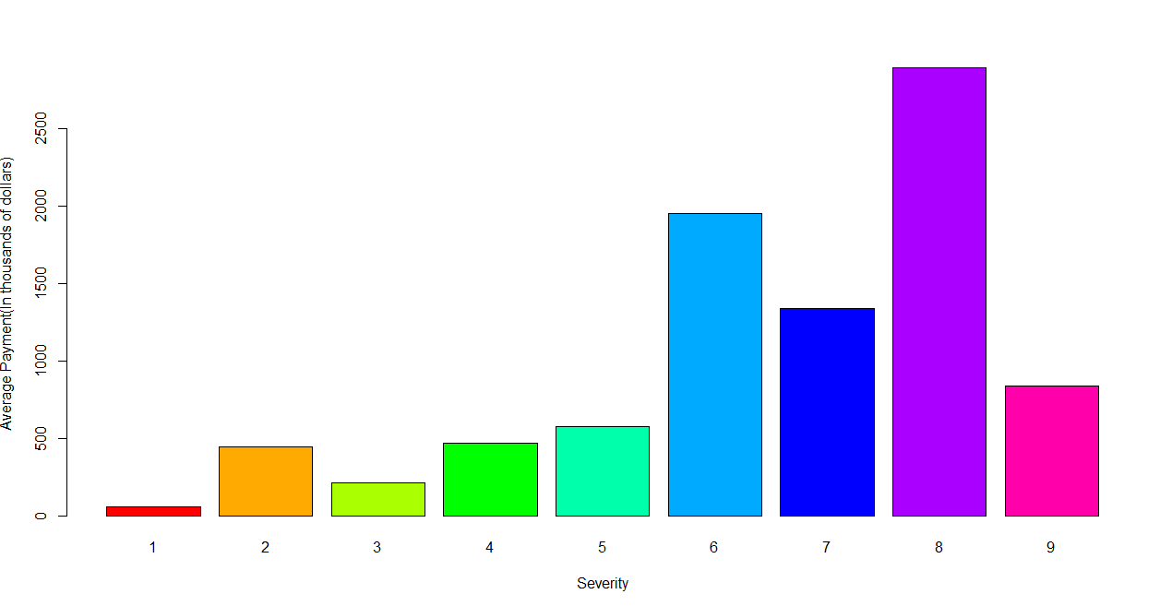

Exhibit D. Age vs Payment

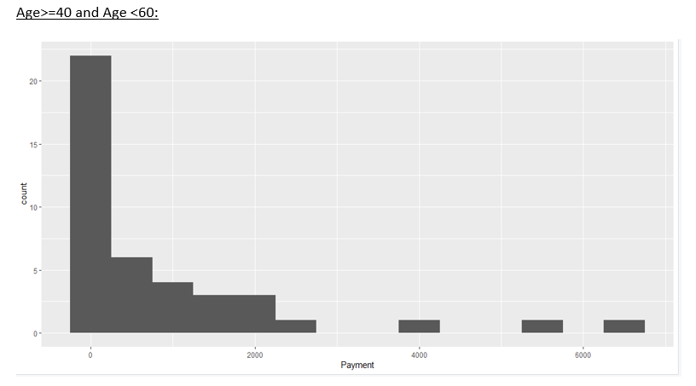

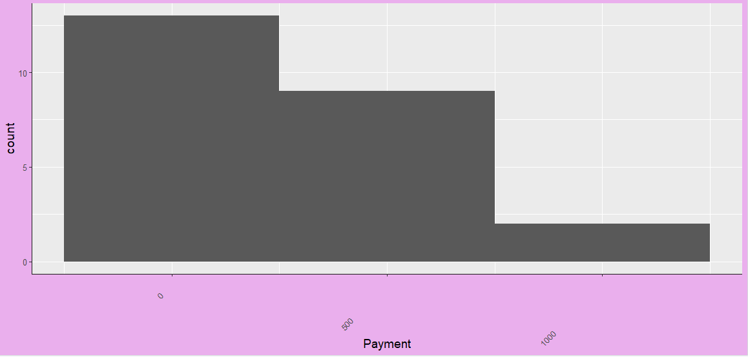Age >=60:

Exhibit D. Bar graph of Private Attorney

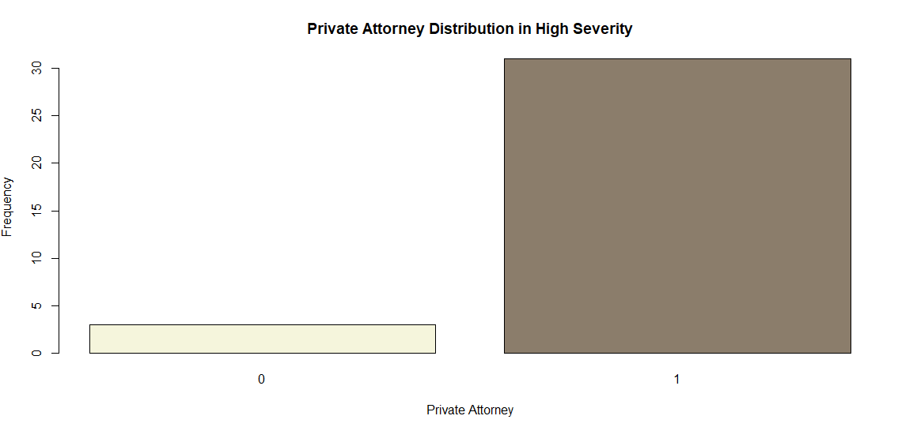

Exhibit E. Surgery vs Medicine for Payment

